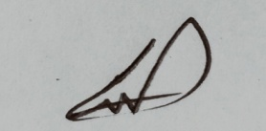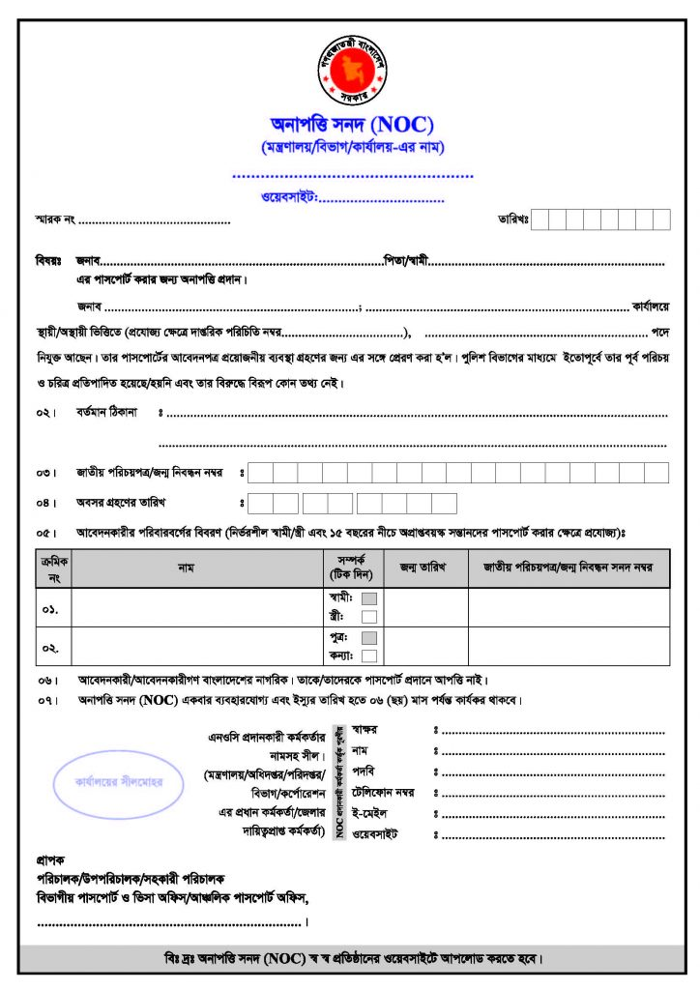

|  |  |  |  |  |  |  |  |  |  |
| --- | --- | --- | --- | --- | --- | --- | --- | --- | --- |
| **1** | **5** |  | **1** | **0** |  | **1** | **9** | **4** | **6** |

|  |  |  |  |  |  |  |  |  |  |
| --- | --- | --- | --- | --- | --- | --- | --- | --- | --- |
| **2** | **3** | **8** | **5** | **6** | **8** | **4** | **0** | **4** | **4** |